Bug ID | TestCase ID-16
Originator | Gorjan Kalauzovic | Email: | Phone:
Submit Date | 22/08/2018
Test prerequisite | https://github.com/gmendonca/gpu-speed-bench/blob/master/SeveralTests/txt/1mb.txt
Summary | When using to postman to search for a search string, if we send a 1mb(or more) search string(found in the prerequisites section), the backend does not gracefully fail , and freezes the application and returns a stacktrace with sensitive data.
Severity | High
Priority | High
Product | Allexis
Component | Backend API search endpoint.
Version | 1.0
Platform | PC
OS | Windows
Browser | None
URL | https://external-api.demo.allexis.io/allexis.b2c.retail.api.external/b2cretailextv1.svc/advancedsearch?vendortoken=a7f39603-5885-4823-9d28-727ee2a2018b

Steps to repoduce
1. Open Postman.
2. Configure the Postman as in the snapshot below.
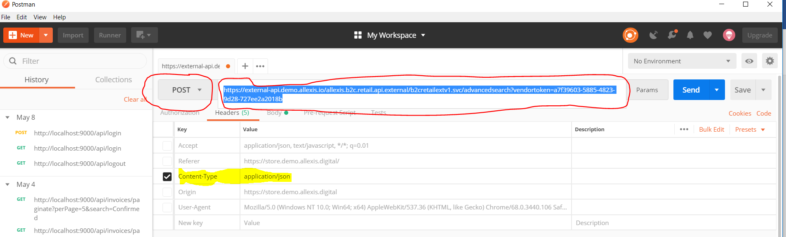

3. Set the body with the 1mb(or more string)
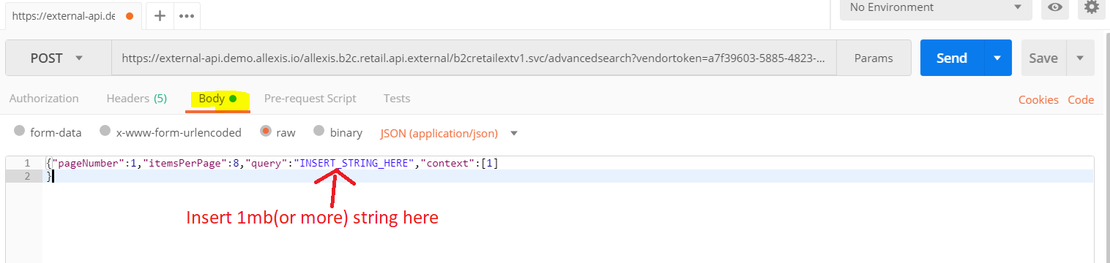

The request should look like this :

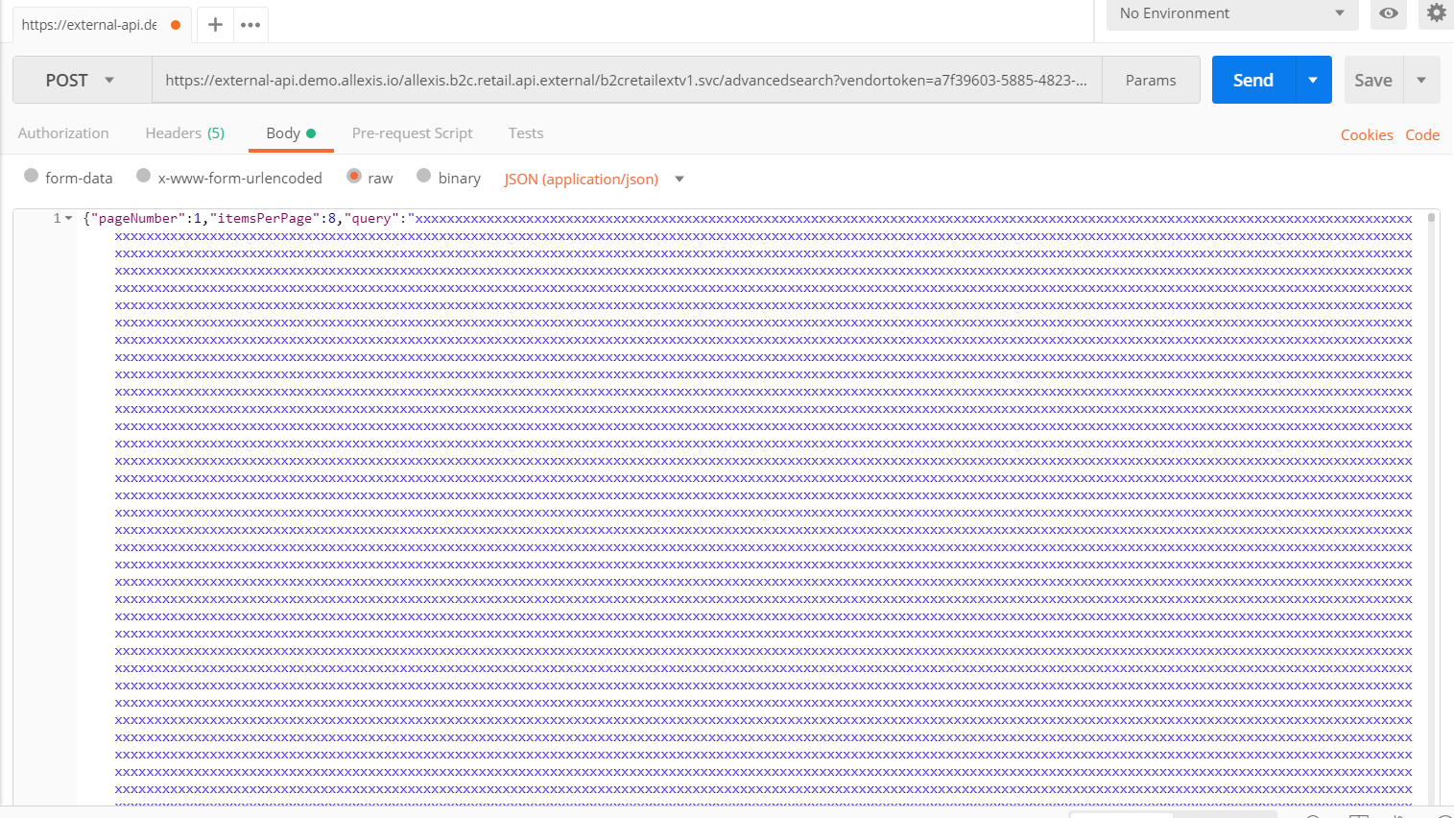

4. Execute post request. We get the response:
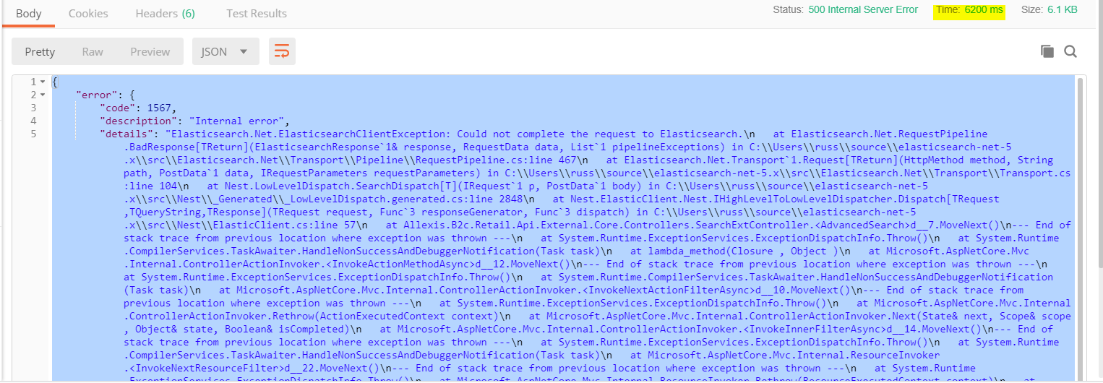

(When using bigger text sizes 5mb and more , Allexis stops its search functionality for up to a minute or crashes and the search functionality stops like in the evening of 22.08.2018)

Exception received with sensitive data is :

Elasticsearch.Net.ElasticsearchClientException: Could not complete the request to Elasticsearch.\n
at Elasticsearch.Net.RequestPipeline.BadResponse[TReturn](ElasticsearchResponse`1& response, RequestData data, List`1 pipelineExceptions) in C:\\Users\\russ\\source\\elasticsearch-net-5.x\\src\\Elasticsearch.Net\\Transport\\Pipeline\\RequestPipeline.cs:line 467\n
at Elasticsearch.Net.Transport`1.Request[TReturn](HttpMethod method, String path, PostData`1 data, IRequestParameters requestParameters) in C:\\Users\\russ\\source\\elasticsearch-net-5.x\\src\\Elasticsearch.Net\\Transport\\Transport.cs:line 104\n
at Nest.LowLevelDispatch.SearchDispatch[T](IRequest`1 p, PostData`1 body) in C:\\Users\\russ\\source\\elasticsearch-net-5.x\\src\\Nest\\_Generated\\_LowLevelDispatch.generated.cs:line 2848\n
at Nest.ElasticClient.Nest.IHighLevelToLowLevelDispatcher.Dispatch[TRequest,TQueryString,TResponse](TRequest request, Func`3 responseGenerator, Func`3 dispatch) in C:\\Users\\russ\\source\\elasticsearch-net-5.x\\src\\Nest\\ElasticClient.cs:line 57\n
at Allexis.B2c.Retail.Api.External.Core.Controllers.SearchExtController.<AdvancedSearch>d__7.MoveNext()\n--- End of stack trace from previous location where exception was thrown ---\n
at System.Runtime.ExceptionServices.ExceptionDispatchInfo.Throw()\n
at System.Runtime.CompilerServices.TaskAwaiter.HandleNonSuccessAndDebuggerNotification(Task task)\n
at lambda_method(Closure , Object )\n
at Microsoft.AspNetCore.Mvc.Internal.ControllerActionInvoker.<InvokeActionMethodAsync>d__12.MoveNext()\n--- End of stack trace from previous location where exception was thrown ---\n
at System.Runtime.ExceptionServices.ExceptionDispatchInfo.Throw()\n
at System.Runtime.CompilerServices.TaskAwaiter.HandleNonSuccessAndDebuggerNotification(Task task)\n
at Microsoft.AspNetCore.Mvc.Internal.ControllerActionInvoker.<InvokeNextActionFilterAsync>d__10.MoveNext()\n--- End of stack trace from previous location where exception was thrown ---\n
at System.Runtime.ExceptionServices.ExceptionDispatchInfo.Throw()\n
at Microsoft.AspNetCore.Mvc.Internal.ControllerActionInvoker.Rethrow(ActionExecutedContext context)\n
at Microsoft.AspNetCore.Mvc.Internal.ControllerActionInvoker.Next(State& next, Scope& scope, Object& state, Boolean& isCompleted)\n
at Microsoft.AspNetCore.Mvc.Internal.ControllerActionInvoker.<InvokeInnerFilterAsync>d__14.MoveNext()\n--- End of stack trace from previous location where exception was thrown ---\n
at System.Runtime.ExceptionServices.ExceptionDispatchInfo.Throw()\n
at System.Runtime.CompilerServices.TaskAwaiter.HandleNonSuccessAndDebuggerNotification(Task task)\n
at Microsoft.AspNetCore.Mvc.Internal.ResourceInvoker.<InvokeNextResourceFilter>d__22.MoveNext()\n--- End of stack trace from previous location where exception was thrown ---\n
at System.Runtime.ExceptionServices.ExceptionDispatchInfo.Throw()\n
at Microsoft.AspNetCore.Mvc.Internal.ResourceInvoker.Rethrow(ResourceExecutedContext context)\n
at Microsoft.AspNetCore.Mvc.Internal.ResourceInvoker.Next(State& next, Scope& scope, Object& state, Boolean& isCompleted)\n
at Microsoft.AspNetCore.Mvc.Internal.ResourceInvoker.<InvokeFilterPipelineAsync>d__17.MoveNext()\n--- End of stack trace from previous location where exception was thrown ---\n
at System.Runtime.ExceptionServices.ExceptionDispatchInfo.Throw()\n
at System.Runtime.CompilerServices.TaskAwaiter.HandleNonSuccessAndDebuggerNotification(Task task)\n
at Microsoft.AspNetCore.Mvc.Internal.ResourceInvoker.<InvokeAsync>d__15.MoveNext()\n--- End of stack trace from previous location where exception was thrown ---\n
at System.Runtime.ExceptionServices.ExceptionDispatchInfo.Throw()\n
at System.Runtime.CompilerServices.TaskAwaiter.HandleNonSuccessAndDebuggerNotification(Task task)\n
at Microsoft.AspNetCore.Builder.RouterMiddleware.<Invoke>d__4.MoveNext()\n--- End of stack trace from previous location where exception was thrown ---\n
at System.Runtime.ExceptionServices.ExceptionDispatchInfo.Throw()\n
at System.Runtime.CompilerServices.TaskAwaiter.HandleNonSuccessAndDebuggerNotification(Task task)\n
at Allexis.Platform.AspNet.Middleware.MultiPathBaseMiddleware.<HandleWithPath>d__5.MoveNext()\n--- End of stack trace from previous location where exception was thrown ---\n
at System.Runtime.ExceptionServices.ExceptionDispatchInfo.Throw()\n
at System.Runtime.CompilerServices.TaskAwaiter.HandleNonSuccessAndDebuggerNotification(Task task)\n
at Allexis.Platform.AspNet.Middleware.MultiPathBaseMiddleware.<Invoke>d__4.MoveNext()\n--- End of stack trace from previous location where exception was thrown ---\n
at System.Runtime.ExceptionServices.ExceptionDispatchInfo.Throw()\n
at System.Runtime.CompilerServices.TaskAwaiter.HandleNonSuccessAndDebuggerNotification(Task task)\n
at Allexis.Platform.AspNet.Middleware.CorrelationIDMiddleware.<Invoke>d__3.MoveNext()\n--- End of stack trace from previous location where exception was thrown ---\n
at System.Runtime.ExceptionServices.ExceptionDispatchInfo.Throw()\n
at System.Runtime.CompilerServices.TaskAwaiter.HandleNonSuccessAndDebuggerNotification(Task task)\n
at Allexis.Platform.AspNet.Logging.RequestLoggingMiddleware.<Invoke>d__3.MoveNext()\n--- End of stack trace from previous location where exception was thrown ---\n
at System.Runtime.ExceptionServices.ExceptionDispatchInfo.Throw()\n
at System.Runtime.CompilerServices.TaskAwaiter.HandleNonSuccessAndDebuggerNotification(Task task)\n
at Allexis.Platform.AspNet.Middleware.XssProtectionMiddleware.<Invoke>d__4.MoveNext()\n--- End of stack trace from previous location where exception was thrown ---\n
at System.Runtime.ExceptionServices.ExceptionDispatchInfo.Throw()\n
at System.Runtime.CompilerServices.TaskAwaiter.HandleNonSuccessAndDebuggerNotification(Task task)\n
at Allexis.Platform.AspNet.Common.JsonExceptionFilter.<Invoke>d__7.MoveNext(

